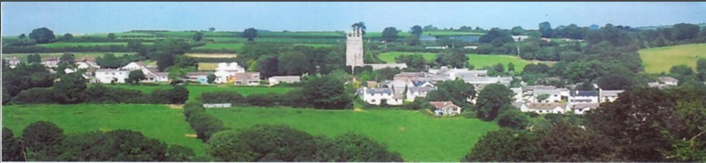
NORTH HILL PARISH COUNCIL ASSET REGISTER
OFFICE EQUIPMENT Checked Value
HP Laptop 18.04.23 £479.98
Laptop Stand 18.04.23 £25.00
HP Printer/Scanner/Copier 18.04.23 £150.00
Epson tank printer 10.03.25 £447.00
COMMUNITY
War Memorial 18.04.23 £2500.00
Telephone Kiosk North Hill 18.04.23 £1.00
Playing Field 18.04.23 £1.00
Play Equipment 18.04.23 £60,000
Centenary Stone 18.04.23 £2500.00
Middlewood Notice Board 18.04.23 £350.00
Defibrillator North Hill 18.04.23 £1500.00
Bathpool Notice Board 18.04.23 £100.00
North Hill Notice Board x2 18.04.23 £200.00
Trebartha Notice Board 18.04.23 £100.00
Congdons Shop Notice Board 18.04.23 £100.00
Pump House at Congdons Shop 18.04.23 £1000.00
Octagonal Bench 18.04.23 £627.20
Disabled Picnic Bench 18.04.23 £396.05
Football Field 18.04.23 £15,000
Salt Bins x 9 18.04.23 £1,000.00
Parish Bier 18.04.23 £500.00
Bus Shelter Congdon’s Shop 18.04.23 £800.00
Graveyard Area 18.04.23 £1.00
Dog Bins x 8 18.04.23 £660.00
Berrio Bridge Notice board 09.05.24 £100.00
Coads Green Notice board 09.05.24 £100.00
Stocks in Church 09.05.24 £400.00
Defibrillator Bathpool 09.05.24 £3,348.00
Defibrillator Congdon’s shop 09.05.24 £1,500.00
Speed Camera 09.05.24 £2807.99
Telephone Kiosk, Coads Green 06.11.24 £1.00
Wooden gate back car park of village hall 14.12.24 £259.00
Total £96,954.00

DATE | AMENDMENT | AMENDED BY | MINUTE NUMBER
09/05/2024 | Added – 2 x notice boards / stocks /2 x defibs / speed camera | Full Council | 2024/10
04/11/2024 | Added – 1 dog bin, 1 salt bin, 1 telephone kiosk | Full Council | 2024/48
03/11/2025 | Added, 1 tank printer / one notice board | Full Council | 2025/62

